
BIT 2304 – PROJECT DEFINITION



Learning Objectives
- What is Data collection and Sampling Techniques?
- Data Collection
- Important statistical terms
- Types of sampling

What is Data collection and Sampling
Techniques?
- Data collection techniques refer to methods used to collect and analyze different forms of data.
- Standard data collection techniques include going through documents related to a topic, as well as conducting interviews and observations.
- Data collection techniques include interviews, observations (direct and participant), questionnaires, and relevant documents (Yin, 2014).
- Others are Transactional Tracking, Social Media Monitoring and Online tracking.
- Sampling means selecting the group that you will actually collect data from in your research.
- For example, if you are researching the opinions of students in your university, you could survey a sample of 100 students.
- In statistics, sampling allows you to test a hypothesis about the characteristics of a population.

Data Collection
  - - In research, statisticians use data in many different ways.
- - Data can be used to describe situations.
  - - Data can be collected in a variety of ways, BUT if the sample data is not collected in an appropriate way, the data may be so completely useless that no amount of statistical torturing can salvage them (GIGO).

Important statistical terms
Population:
a set which includes all measurements of interest to the researcher
(The collection of all responses, measurements, or counts that are of interest)

Sample:
A subset of the population

Why sampling?

Get information about large populations
⬇ Less costs
⬇ Less field time
⬆ More accuracy i.e. Can Do A Better Job of Data Collection
 When it’s impossible to study the whole population

Target Population:
The population to be studied/ to which the investigator wants to generalize his results
Sampling Unit
Smallest unit from which sample can be selected Sampling frame
List of all the sampling units from which sample is drawn Sampling scheme
Method of selecting sampling units from sampling frame

Types of sampling

- Non-probability samples

- Probability samples

Non probability samples

- Convenience samples (ease of access)
sample is selected from elements of a population that are easily accessible
- Snowball sampling (friend of friend….etc.)
- Purposive sampling (judgemental)
  - You chose who you think should be in the study
  - Quota sample

Non probability samples

Probability of being chosen is unknown Cheaper- but unable to generalise potential for bias

Probability samples

- Random sampling
  - Each subject has a known probability of being selected
- Allows application of statistical sampling theory to results to:
  - Generalise
  - Test hypotheses

Conclusions

- Probability samples are the best

- Ensure
  - Representativeness
  - Precision

Methods used in probability samples

    - Simple random sampling
    - Systematic sampling
    - Stratified sampling
    - Multi-stage sampling
    - Cluster sampling

13 MOD 4 - Data Collection & Sampling

Simple random sampling

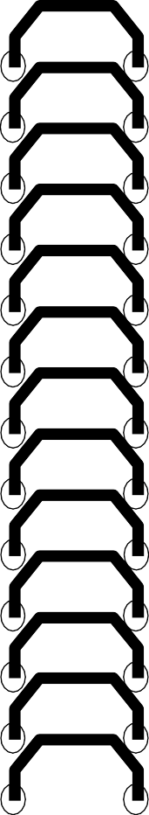
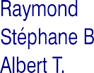



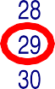

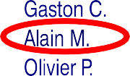

14 MOD 4 - Data Collection & Sampling

Table of random numbers

6 8 4 2 5 7 9 5 4 1 2 5 6 3 2 1 4 0
5 8 2 0 3 2 1 5 4 7 8 5 9 6 2 0 2 4
3 6 2 3 3 3 2 5 4 7 8 9 1 2 0 3 2 5
9 8 5 2 6 3 0 1 7 4 2 4 5 0 3 6 8 6

Systematic sampling

Sampling fraction
Ratio between sample size and population size

16 MOD 4 - Data Collection & Sampling

Systematic sampling







17 MOD 4 - Data Collection & Sampling

Cluster sampling
Cluster: a group of sampling units close to each other i.e. crowding together in the same area or neighborhood

18 MOD 4 - Data Collection & Sampling

Cluster sampling
Section 1
Section 2

Section 3

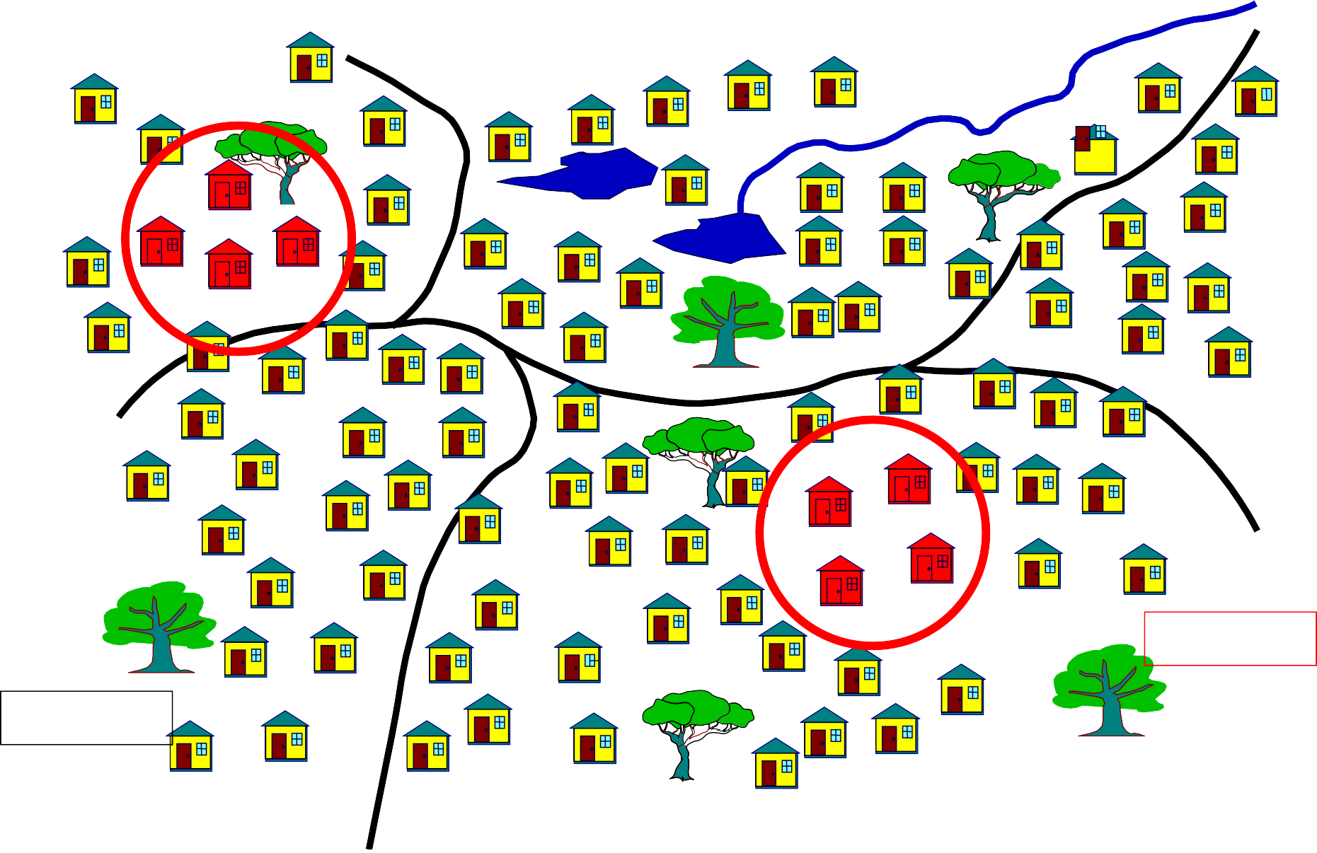
Section 5

Section 4
MOD 4 - Data Collection & Sampling techniques 19

- Stratified sampling: With stratified sampling, the researcher divides the population into separate groups, called strata. Then, a probability sample (often a simple random sample ) is drawn from each group.
- Stratified sampling has several advantages over simple random sampling.

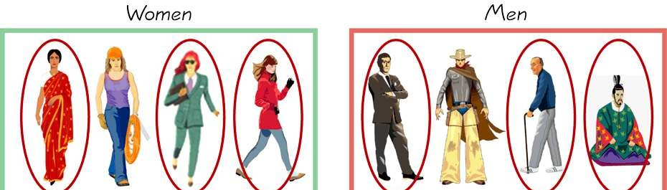
MOD 4 - Data Collection & Sampling
20 techniques

Multi-stage sampling

- -Is a sampling strategy (e.g., gathering participants for a study) used when conducting studies involving a very large population.
- -The entire population is divided into naturally-occurring clusters and sub-clusters, from which the researcher randomly selects the sample.

- - For example, you want to conduct a survey of salespeople for a nationwide retail chain with stores all over the country.
- -You could:
- randomly select states
- randomly select counties in each state
- randomly select stores in each county, and
- randomly select salespeople in those stores

Errors in sample

  - Systematic error (or bias)
Inaccurate response (information bias) Selection bias
An error having a nonzero mean, so that its effect is not reduced when observations are averaged.

  - Sampling error (random error):- Error in a statistical analysis arising from the unrepresentativeness of the sample taken.

Type 1 error

- The probability of finding a difference with our sample compared to population, and there really isn’t one….

- Known as the α (or “type 1 error”)

- Usually set at 5% (or 0.05)

Type 2 error

  - The probability of not finding a difference that actually exists between our sample compared to the population…

  - Known as the β (or “type 2 error”)

  - Power is (1- β) and is usually 80%

Precision
Cost





